*Problem 1:*

*Missionaries and Cannibals Problem: Three Missionaries and three cannibals are*

*on the left bank of a river. There is a boat on their side of the river that can be used to*

*carry one or two people. The goal is to use this boat to cross the river in such a way that*

*cannibals never outnumber missionaries on either bank of the river.*

*Solution:*

*Initial state:*

*It is the state when Cannibals and Missionaries are on the left bank of the river with boat.*

*I stated this state with (3,3,1)*

*Successor Function:*

*Cannibals never outnumbered the missionaries on either side of the river.Which means the missionaries will always be more in number than the cannibals.*

*Final state:*

*Final state is they all cross the river and go to the other side.*

*Which I stated as (0,0,0).*

*State space diagram is drawn below:*

*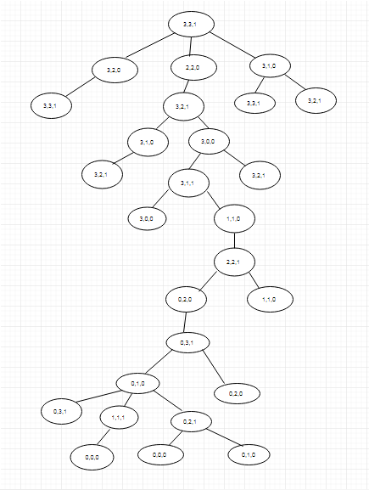*

*To solve this problem, I used DFS because it will take less steps than BFS.The solution is given below:*

*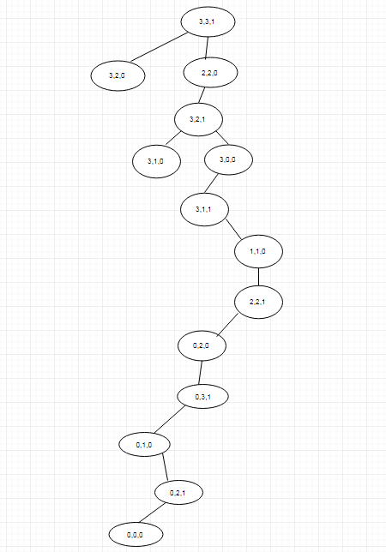*

*Problem 2:*

*Lion, Lamb and grass problem: A person has one lion, one lamb and a bundle of*

*grass. He wants to cross a river but there is only one boat and it can’t sustain the weight*

*of more than two articles at time. Also, he has to make sure that the lion doesn’t eat the*

*lamb and the lamb doesn’t eat the grass. How will he get to the other side of the river*

*with all three intact?*

*Solution:*

*Initial state:*

*It is the state when Lion,Lambs and grass are on the left bank of the river with boat.*

*I stated this state with (L,La,gs,1)*

*Where L=Lion*

*La=Lamb and gs=Grass ,*

*1 means boat on that side and*

*0 means boat on the other side.*

*Successor Function:*

*Lion doesn’t eat the Lamb and the Lamb doesn’t eat the grass*

*Final state:*

*Final state is they all cross the river and go to the other side.*

*Which I stated as (0,0,0,0).*

*State space diagram is drawn below:*

*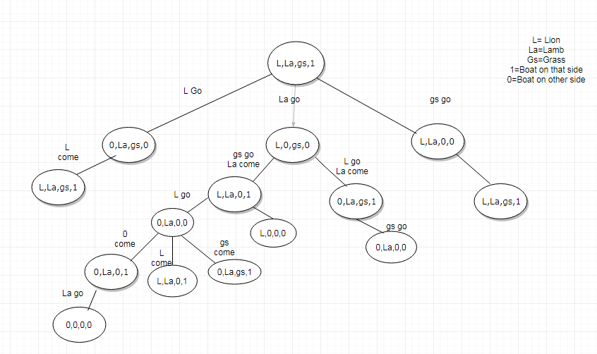*

*To solve this problem, I used DFS because it is optimal solution.*

*The solution is given below:*

*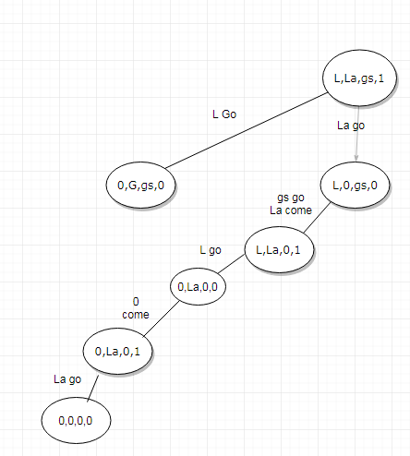*

*Problem 3:*

*Man, Woman and two children problem: A man and a woman of equal weight,*

*together with two children, each of half their weight, wish to cross a river using a boat*

*which can only carry the weight of one adult. The goal is to use this boat to cross the*

*river.*

*Solution:*

*Initial state:*

*It is the state when man,woman and two children are on the left bank of the river with boat.*

*I stated this state with (2A,2C,1)*

*Where A=Adult*

*C=Children*

*1 means boat on that side and*

*0 means boat on the other side.*

*Successor Function:*

*Goal is to use this boat to cross the river.*

*Final state:*

*Final state is they all cross the river and go to the other side.*

*Which I stated as (0,0,0).*

*State space diagram is drawn below:*

*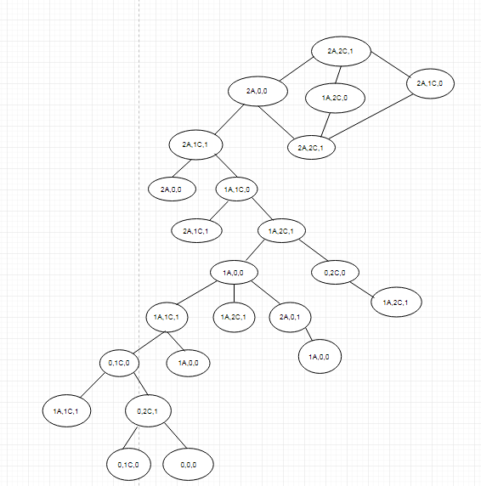*

*To solve this problem, I used DFS because it is optimal solution.*

*The solution is given below:*

*